THE OFFICIAL NEWSLETTER OF THE MORRIS CAR CLUB (VIC) Inc. A0017484
The Bull’s Eye
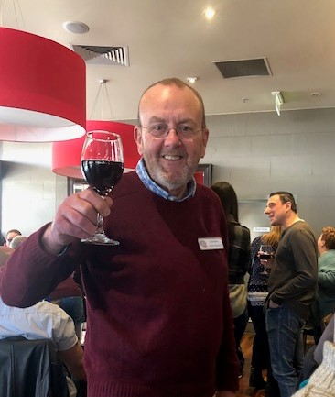

Next meeting Tuesday 6th August
@ Pascoe Vale RSL
EVERYONE WELCOME
July 2019
Hello members and friends,
The Winter Solstice has passed and there are events every month leading up to Christmas for you to get involved with. Welcome to our newest members, John and Annette, Chris and David, it is pleasing to have your involvement and your wonderful cars as well. I hope you have a long and happy involvement.
This month’s bowling tournament with the Rootes Car Club was very well received and I enjoyed meeting the members from both clubs in attendance. Congratulations Shayne Martin on winning the day with his top score. Congrats also to Chris Read (Andrew’s son fresh from Darwin) on his second place and to Tony Bullen (currently somewhere in Africa) on his third place.
On the matter of attendances, our bylaws (these can be found on the web site) stipulate that members should attend at least four activities each year to sustain their membership. One of the goals we have set in our current strategic plan is to have more members participating in outings. I believe the monthly outings are the best way to share time and to discuss issues regarding the management and restoration of your club vehicle. If you haven’t been to an event lately, please check the calendar on the website and take the plunge to jump in and engage with your co-members – greater member participation benefits everyone.
Our club’s Show and Shine is fast approaching as is this year’s Motorclassica. This year’s Show and Shine will be held at Little River and will be a test run for a much larger event next year where will be inviting members from other BMC clubs to enter their vehicles and to promote BMC more proactively to classic car enthusiasts. In terms of Motorclassica, we had an excellent turn up of vehicles last year and those that did attend we very impressed with the interaction they had with classic car enthusiasts. This year the club members attending will have their own supply of club promotional literature to encourage more new members to the club.
I look forward to catching up with you in the coming months.
Stephen Whitworth
President
Morris Car Club of Victoria Inc.

Run Report - Ten-Pin Bowling challenge

It was another great day out for our annual Ten pin bowling challenge with the Rootes Group Club. There were 19 people in attendance and am happy to report the Morris car club has taken back the title this year. The over all winning was Shane with 130 followed by Chris and Tony. I had my own personal achievement of the first time ever beating my husband who may have had a pulled hamstring at the time, but wining is winning.
We then enjoyed lunch at Café Greko, I was a fun day out and I look forward to next year’s event.
Jo-Anne Davis

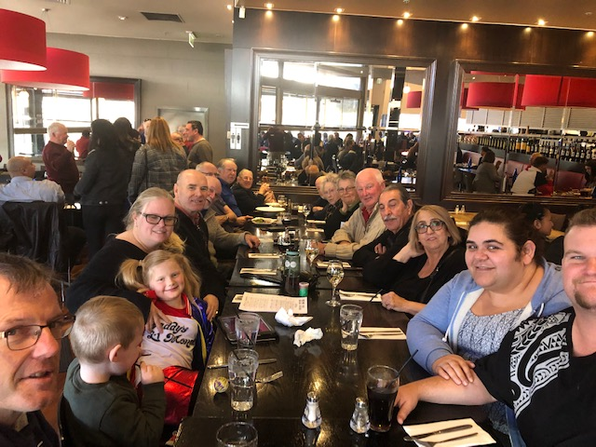

TECH TIME

Tuning a Morris Oxford MO
I have had Bessie my trusty Morris Oxford for about ten years, and these are the things I have tried to improve performance a little.
I fitted an electronic ignition system then upgraded the coil to a high powered sports coil. The original coil was rated at 12,000volts, the replacement 40,000 volts, so the next step was to give the spark plugs wider gaps, the reasoning being bigger spark, better burn of the fuel mixture. All sound reasonable… well not exactly.
This is the history of spark plug gaps 1940s to mid-1950s. Side-valve engines were usually 18 thou to 22 thou. Jump forward to the 1980s with fuel injection and engine management systems, spark plug gaps increased to 40 thou or greater. (This is because a leaner fuel mixture needs a much bigger spark to ignite, and a bigger spark needs a bigger coil. A richer, more dense air-fuel mix needs a short fat spark to ignite it; a long thin spark does not work as well.) So now, let’s go back in time to 1952 to a 1476 cc side-valve engine built for simplicity and reliability, not high performance. So this is what works best, points gapped at 10 thou, spark plugs gapped at 18 thou, and ignition timing TDC. When the car was first released the motor writers said it would do 25 mpg, with better fuel combined city highway driving just on 27 mpg. The best highway only result has been 29 mpg. The only three modern things I have tried, which actually improved things, was a Gunnson colour tune to set the SU carburettor mixture, and a sports coil gives better spark, therefore easier starting. I have also converted the oil bath air filter to take a paper filter. It made a big improvement to the inlet air flow. I have found keeping the motor that was designed low tech to original settings and equipment, where possible, the more reliable it will be. You won’t have the electronic ignition failing in the right hand turning lane with nowhere to go, or ignition leads burning out because they can’t carry the voltage for the bigger spark plug gaps. I have left the sports coil on the car with the smaller plug gaps- no more burnt out plug leads and the coil barely gets warm. With the bigger plug gaps it got extremely hot and when you think about it our classic cars, would only clock up 5 to 7 thousand miles a year so you might need to look at the points once a year. I give Bessie a full grill to boot service once a year. Full tune to manufacturer’s specs including full grease, motor gear box and diff oil change, flush brake fluid and adjust brakes. The last ingredient to keeping your classic car reliable is to get it out for a good run every few weeks, they don’t like not being used. A modern car you can ignore for months and it won’t make much difference but classics need to be driven. It solves a lot of reliability problems and you catch small problems before they turn into big problems.
Tony Bullen

Calendar of events
July
27th A Sunday Drive on a Saturday- Today we are off for a drive in the country. We will start by having a coffee in Woodend and may be a cake. Then, we will take the scenic route to Kyneton via Turpins Falls, and then lunch in Kyneton in one of the many cafés or pubs (a booking will be made prior). Then time for a look through some of the antique shops before afternoon tea and heading home.
Meeting point: Calder Park BP
Time: 10 am for a 10.30 start
Distance: 60 Kilometres. We will be traveling in convoy.
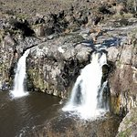

August
25th Geelong museum of motoring history- Today we are off to the Geelong Museum of Motoring and Industry, 23 Waymouth Street Hamlyn Heights, Geelong. This will be followed by lunch at Ripples restaurant at 42 Bell Parade, Rippleside, Geelong. This is not far from the museum so a day of motoring history with food and drinks, coffee, beer, wine, and soft drink. So get your classic out and join us!
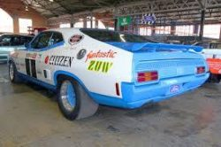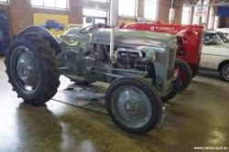
Admission to the museum is $15 adult; children and concession $10; family $30
Distance 86 kilometres
Time 1 hour 10 minutes
Meeting at Laverton North McDonalds, 9am for a 9.30am start
We will be travelling in convoy so all leave together

September
8th Show and Shine - The annual Show and Shine will be on again on Sunday 8th September, so get the classics dusted and polished, and put them in the competition. The location this year is the Mechanics Hall, 24 Rothwell Street, Little River. Also, on the day we will be going on a historical town walk; more information on this closer to the event.
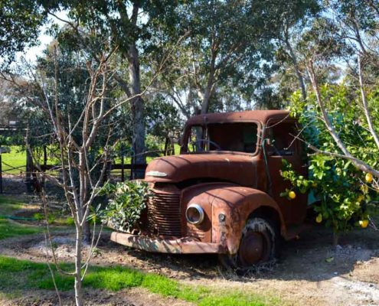

October
13th Motorclassica 2019 - Today we are off to Motorclassica to support our members, and other clubs that have their cars on display in the ‘club sandwich’. Due to parking I suggest we all use public transport or park your modern car nearby and walk; we will meet in the museum forecourt between the ticket box and the museum. There will be lots of very nice cars on display both inside and out.
Meeting time: 10.00am
Place: Forecourt, near ticket box
Admission: Adult $39; Child $20; Family $90

Classifieds
If anyone has anything they would like to sell please email me at joeyejdavis@gmail.com and I will put it in.

Committee contact details
2019-2020 MCCV Committee
President Stephen Whitworth- Stephen,whitworth3@gmail.com - 0419310031
Vice President Tim Christie - timothychristie@bigpond.com - 0409 966 942
Secretary Bevan-Rhys James - bevan@brjames.com.au
Treasurer Geoff Meehan- 0400 961 123
Club Captain Tony Bullen- 0402 528 652
Bull’s-Eye Editor Jo-Anne Davis- joeyejdavis@gmail.com
Web master Andrew Read- A.Read.BoM@gmail.com
Club Ambassador Alain Ribas
Club Scrutineer Rod Bowers

