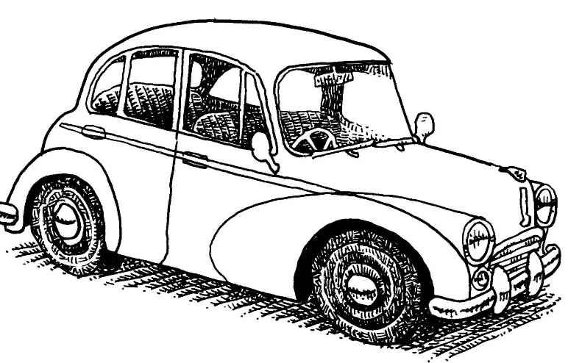

THE OFFICIAL NEWSLETTER OF THE MORRIS CAR CLUB (VIC) Inc. A0017484
The Bull’s Eye
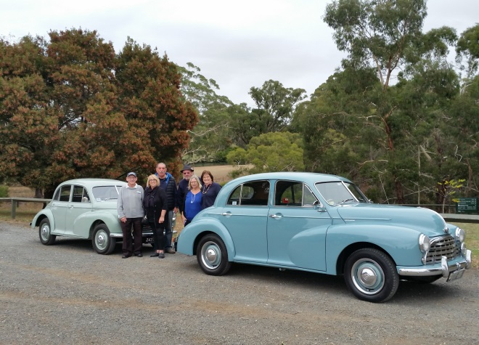

Next meeting Tuesday 4th June
@ Pascoe Vale RSL
EVERYONE WELCOME
June 2019

Hello members and friends of the MCCV
In my first column as President, I want to begin by saying thank you to Tim for his work over the past two years; we have taken some very positive steps to regroup and rebuild our club. Tim remains a member of the committee as Vice President and for that I am grateful. I am also pleased to say that the rest of past committee have also remained with the addition of Jo-Anne and Rod (see panel below for the new committee details).
I mentioned at the AGM that I want to begin the process of a two to five-year plan for the club. Why a plan? There is a saying “fail to plan, plan to fail”. I recently sent an email inviting all members to contribute to the strategy. I would encourage you to take a few minutes to put down your thoughts and send these back to me as soon as you can.
The document we produce will be a living document; as we achieve certain targets, we will update the document. My priority focus is on growth in membership and growth in numbers at our events and runs. I would like to see more project vehicles when we take to the country for outings. I have noticed every time we arrive at a meeting point that there is a great deal of interest in the vehicles which hopefully, we will be able to convert to a larger number of new members.
In today’s world we need more material that can be used to harvest interest from the public. First on the list will be brochures for every member to keep in the glovebox of their cars (not a new idea but one that needs revitalizing). These brochures can be used when individuals approach you or other members interested in knowing more about the MCCV.
The second strand of promotion will be an increased PR presence in motoring magazines and social media, again aimed at increasing interest from potential members.
Thirdly, and I appreciate the Club’s history a few years back, but we need to focus on the future more than we currently do. Finally, a big thanks to Jo-Anne Davis for taking on the role of editor; much appreciated and please send your articles, pics or trivia to make her task just that little bit easier.
Stephen Whitworth
President MCCV Inc.

2019-2020 MCCV Committee
President Stephen Whitworth
Vice President Tim Christie
Secretary Bevan-Rhys James
Treasurer Geoff Meehan
Club Captain Tony Bullen
Bull’s-Eye Editor Jo-Anne Davis
Web master Andrew Read
Club Ambassador Alain Ribas
Club Scrutineer Rod Bowers

Run Report Hepburn Springs Outing
Again we had great weather to get our classics out and on this trip there were no break downs or lost travellers - we all left together and arrived together - something to be said for that idea! We passed through Leonards Hill and Sailors Falls on the way to Hepburn Springs. Due to the past dry seasons, no water was going over the falls but still a very pretty spot to stop. My family come from the area so I knew a fair amount of the local history; I used to collect the eggs for my great Grandmother out of her hen house just up the road about a kilometre! I would travel there with my grandparents in Bessie, so for Bessie and I it was a trip down memory lane. Once at Hepburn Springs we went for a walk and tasted the water from many different pumps - some pumps were better than others. We had a picnic lunch in a great shelter with tables and BBQ which we had all to ourselves. After lunch we went into Daylesford to look around the antique shops. As you can see in the photo, Stephen found a hat which brought Professor Moriarty out in him. Sherlock Holmes would have been most impressed! Later we found a coffee shop for scones and coffee before we headed home. Thanks to all who attended, you made it a very enjoyable day.
In Attendance were: Bill Flaherty (Morris Minor); Tony and Marilyn Bullen (Morris Oxford); Joyce and Joe Farsaci, and Elaine Booker (modern); Stephen Whitworth (modern). 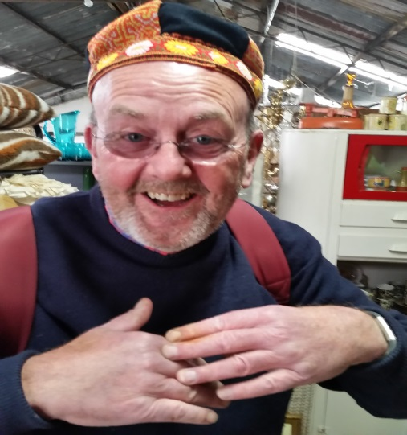 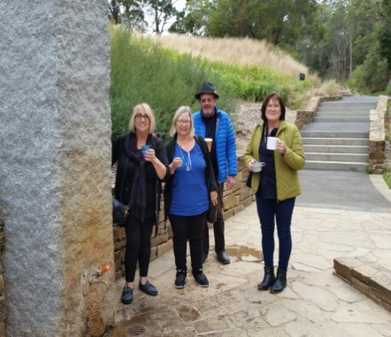
Tony Bullen
Club Captain

Run Report Pig and Whistle
Firstly, I would like to welcome our new members, John and Annette Brooksmith, to our club and our happy band of travellers. I hope this outing was the first of many. Well, what a great day - the best turnout to a club outing in a long time! Thank you every one that attended, you made the day the enjoyable day it was. As planned, we met at Calder Park BP. Blue skies, not to cold, nice weather for a drive to a country pub for lunch and a relaxed afternoon, which was good because John and Annette were in an ex-army Moke. Not the warmest of cars on a cold damp day!
I was in the lead, Stephen was tail-end Charlie, and another trip without losing anyone; we left together and arrived together. By the time we got to Gisborne the weather started to change, and by the time we reached Woodend it was overcast and cold. Trentham put on some of its best weather, freezing and wet, with a touch of foggy mist. It was a great day to be indoors, eating hot food, with great company and a nice warm fire.
Some members drove a distance to join the outing including Graeme Williamson from Lang Lang who drove his new pride and joy, a Wolseley 24/80; Shane Martin came from Geelong in the big Morris Marshall; and Bill Flaherty drove his Morris Minor from Hoppers Crossing. Other members who attended were the Brooksmiths in their army Moke; Ann and Rob Quinn in their Morris Minor ute; Tony and Marilyn Bullen in their Morris Oxford MO; Scott and Penina Booker (modern); Elaine Booker (modern); Jo-Anne and Kye Davis (modern); Bevan-Rhys James and wife (modern); and Stephen Whitworth (modern).
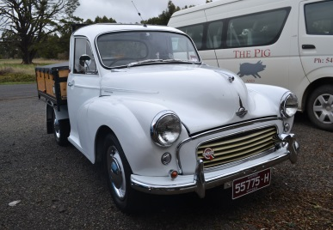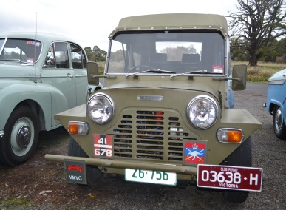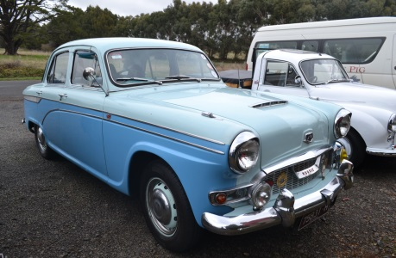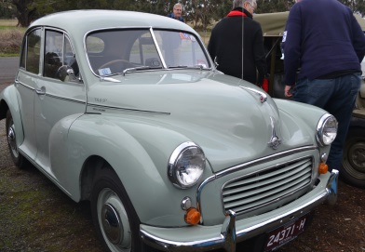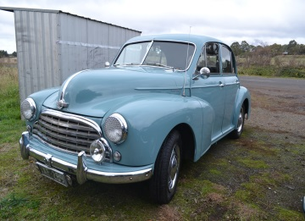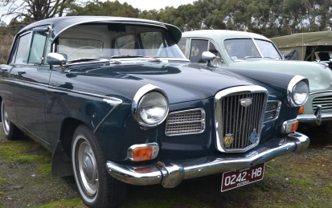
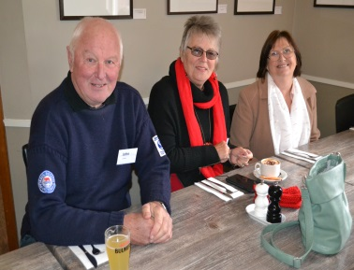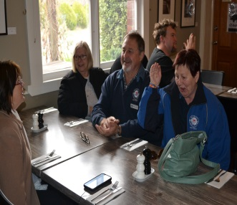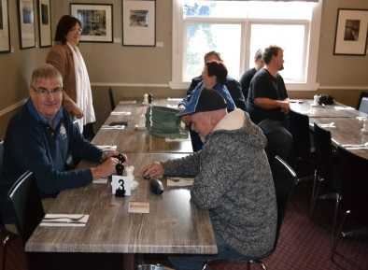
Club Captain
Tony Bullen
Calendar of events
June
8th – 10th 2019 Morris Car Club Jamboree - The Annual Jamboree at Stanhope

30th Ten-Pin Bowling challenge - It’s on again, the annual ten-pin bowling interclub challenge; the MCCV against the Rootes Group Club. I might mention that we lost badly last year so we might need to train for this comp, or maybe just ‘will’ the ball to go straight! Personally, I will need the bumper rails up as last time that’s where 10% of my balls went – straight down the gutter!
We will be having lunch after the comp at a restaurant in the Watergardens Shopping Centre, a short walk from the bowling alley.
Where: Zone Bowling, 399 Melton Highway, Taylors Lakes. Melways 13 E1
Meet at the venue. 10.30AM
Bring your RACV card

July
27th A Sunday Drive on a Saturday- Today we are off for a drive in the country. We will start by having a coffee in Woodend and may be a cake. Then, we will take the scenic route to Kyneton via Turpins Falls, and then lunch in Kyneton in one of the many cafés or pubs (a booking will be made prior). Then time for a look through some of the antique shops before afternoon tea and heading home.
Meeting point: Calder Park BP
Time: 10 am for a 10.30 start
Distance: 60 Kilometres. We will be traveling in convoy.
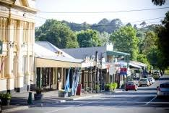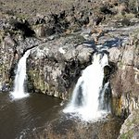

August
25th Geelong museum of motoring history- Today we are off to the Geelong Museum of Motoring and Industry, 23 Waymouth Street Hamlyn Heights, Geelong. This will be followed by lunch at Ripples restaurant at 42 Bell Parade, Rippleside, Geelong. This is not far from the museum so a day of motoring history with food and drinks, coffee, beer, wine, and soft drink. So get your classic out and join us!
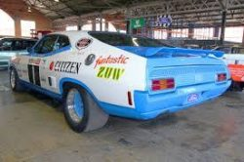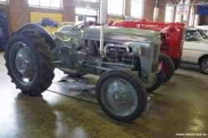
Admission to the museum is $15 adult; children and concession $10; family $30
Distance 86 kilometres
Time 1 hour 10 minutes
Meeting at Laverton North McDonalds, 9am for a 9.30am start
We will be travelling in convoy so all leave together

September
8th Show and Shine - The annual Show and Shine will be on again on Sunday 8th September, so get the classics dusted and polished, and put them in the competition. The location this year is the Mechanics Hall, 24 Rothwell Street, Little River. Also, on the day we will be going on a historical town walk; more information on this closer to the event.
October
13th Motorclassica 2019 - Today we are off to Motorclassica to support our members, and other clubs that have their cars on display in the ‘club sandwich’. Due to parking I suggest we all use public transport or park your modern car nearby and walk; we will meet in the museum forecourt between the ticket box and the museum. There will be lots of very nice cars on display both inside and out.
Meeting time: 10.00am
Place: Forecourt, near ticket box
Admission: Adult $39; Child $20; Family $90

Classifieds
If anyone has anything they would like to sell please email me at joeyejdavis@gmail.com and I will put it in.

10 Fun Car Facts You Probably Didn’t Know
- Cars were seen as the “green” alternative of transportation in the early 20th century because horses were causing so much pollution with their poop.
- The Honda CR-V originally came with a picnic table.
- The Ford GT broke the crushing machine used in the “roof crush” safety test because it’s so strong.
- In Russia, it’s a criminal offense to drive around in a dirty car.
- 75% of cars that Rolls-Royce has ever produced are still on the road today.
- If you want to travel to the moon, it would take less than 6 months if you drive at 60 mph.
- The “new car smell” is composed of over 50 volatile organic compounds—none of which are toxic.
- The first car accident occurred in 1891 in Ohio.
- The average American spends about 38 hours a year stuck in traffic.
- In Los Angeles, there are more cars than people.

Reference ; https://thenewswheel.com

Committee contact details
2019-2020 MCCV Committee
President Stephen Whitworth- Stephen,whitworth3@gmail.com - 0419310031
Vice President Tim Christie - timothychristie@bigpond.com - 0409 966 942
Secretary Bevan-Rhys James -
Treasurer Geoff Meehan- 0400 961 123
Club Captain Tony Bullen- 0402 528 652
Bull’s-Eye Editor Jo-Anne Davis- joeyejdavis@gmail.com
Web master Andrew Read- A.Read.BoM@gmail.com
Club Ambassador Alain Ribas
Club Scrutineer Rod Bowers

