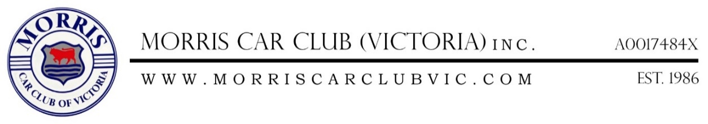

Hello Members,
As you may know our Annual General Meeting is fast approaching, it will be held on Tuesday 2nd April 2019.
In preparation for this the Committee enclose Committee Nomination Form for the 2019-2020 year.
If you would like to nominate for a position or nominate someone for a position please fill in this form and return it to the Club Secretary before the start of the meeting on the Night. Please don't forget that if you would like to be nominated or would like to nominate a fellow member you both have to be financial members of the club for the 2019-2020 year; this must be done at least 7 days before the meeting is held as to comply with the Model Rules.
As to follow the Model Rules we will not be taking nominations from the floor on the night, so the only way to fill the positions is if you are nominated or you nominate a fellow member.
We have attached a copy of the Nomination Form and the 2019-2020 Membership Renewal Form.
If you would like to see the club continue to grow and improve please put your hand up and join the Committee as this is the only way Our Club will continue to survive and get bigger and better.
Hope to see you all soon at an upcoming run or two and at the AGM in April and let’s make 2019 year of Morris Car Club (Victoria) Inc. a fantastic year.
Yours in Morrying

Bevan-Rhys James
Morris Car Club (Victoria) Inc.
Secretary

Postal: Po Box 486
Heidelberg Vic 3084
Mobile: 9458 3711 or 0432 379 068
Email – bevan@brjames.com.au

